**Customize the App interface to Display the Values**

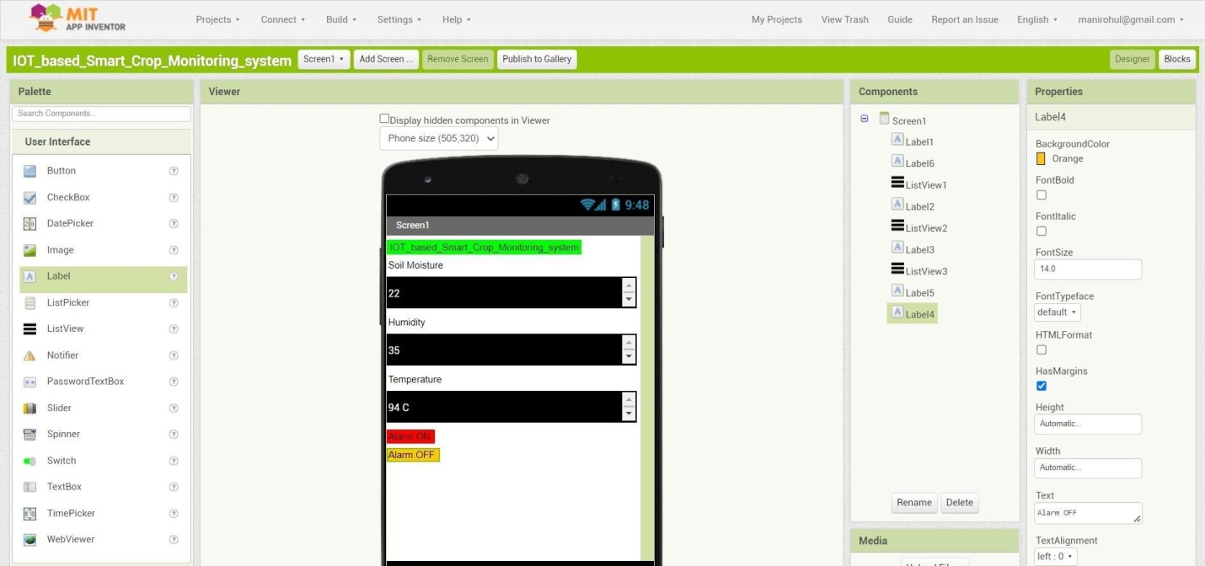

**MIT APP inventor to design the APP**

